Omni Glucose Tracker

User Requirements Document

[ Version 1.1 ]

CMU ECE
_________________________________________________________________

Omni Glucose Tracker

User Requirements Document
[Version 1.0]

Prepared By Inspected/Reviewed By Approved By

NAME: Zhengkun Dai, Baihu Qian

TITLE:

SIGNATURE:

DATE: May 2, 2014

VERSION HISTORY

Version No. | Date | Changed By: | Changes Made:
1.0 | March 28, 2014 | Zhengkun Dai  Baihu Qian
1.1 | May 2, 2014 | Zhengkun Dai  Baihu Qian | Finalized

User Requirements Document

Table of Contents

I. Introduction 2
Document Scope 2
Intended Audience 2
References 2
System Overview 3
General Requirements 3
System in Context 3
User Characteristics 4
Constraint 4
System Requirements 4
System Operation Rules 4
Detailed Requirements 5
Requirements Overview 5
Functional Requirements 5
User Requirements Model – Use Case Overview 5
User Requirements Model – Detailed Use Case Specifications 6
Technical Requirements 8
Operational and Development Environments 8
APPENDIX A I
Glossary of Terms I

User Requirements Document

I. Introduction

The objective of the User Requirements Document (URD) is to specify the requirements the user expects. The URD avoids technical implementation language, and restricts notations used to those that express functionality from a user’s viewpoint.

Document Scope

This URD provides an overall description of OmniGlucoseTracker (OGT), as well as detailed descriptions of all of its intended functionality. Object-Oriented Design methodology and Use Case Analysis are utilized in this URD to describe the general requirements, technical requirements, architecture, and usage scenarios.

The URD will describe the following information:

- OGT structures
- OGT functionalities
- System users

Intended Audience

The primary audience for this document is:
- Software Development Team
- Users
- Guardians
- Doctors

References

- tidepool.org

System Overview

OGT provides an intuitive way for Type I Diabetes patients to record their glucose levels and daily activities. OGT can help users to adjust their activities to keep their glucose levels in the normal range. OGT can also seek others’ help in case of emergency. User data can be exported or shared under user’s permission for treatment or research purposes. The goal of OGT is to help users to predict and avoid potential dangerous situations and help doctors to provide better treatment.

General Requirements

The purpose of this section is to describe the characteristics of OGT.

System in Context

OGT is a user friendly app to keep a record of users’ glucose levels and daily activities. OGT needs to store the data of users’ activities and glucose levels.
The basic user’s data, which includes steps, location and time, are recorded automatically by OGT.
User can also input special activities to OGT to keep a detailed record.
User’s glucose level is input manually to OGT. In the future, automatic recording can be applied if the glucose meter has the communication functionality.
OGT will act as a communication tools between users, guardians and doctors.
If the glucose level is in the dangerous range, OGT will remind the user to take proper actions.
If the glucose level is extremely low, OGT will contact the guardian and designated friends immediately.
Guardians and Doctors can view the user’s glucose level. Guardians can send message to user’s client.

System in Diagram
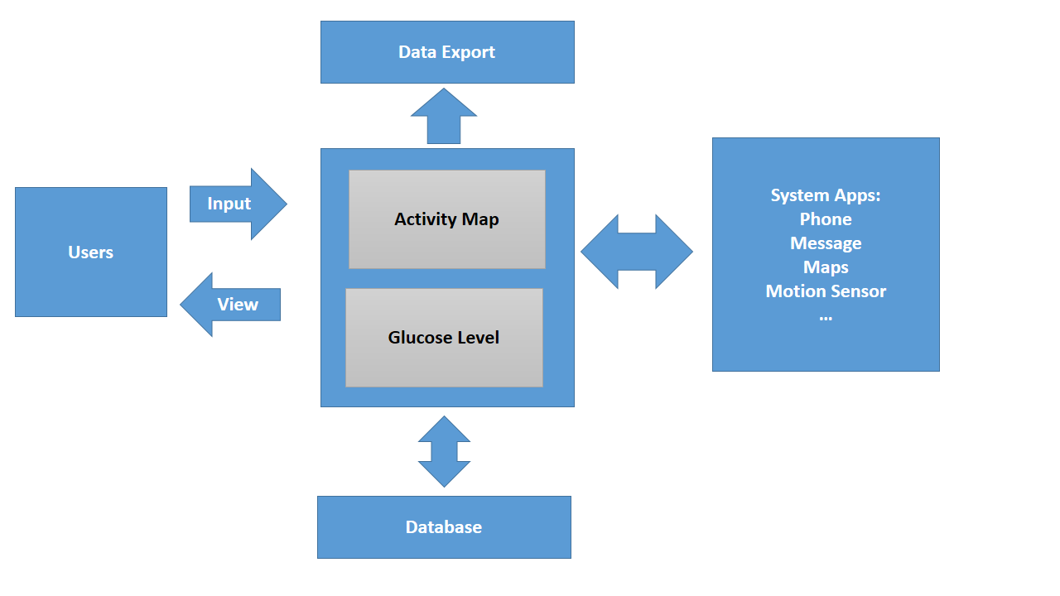

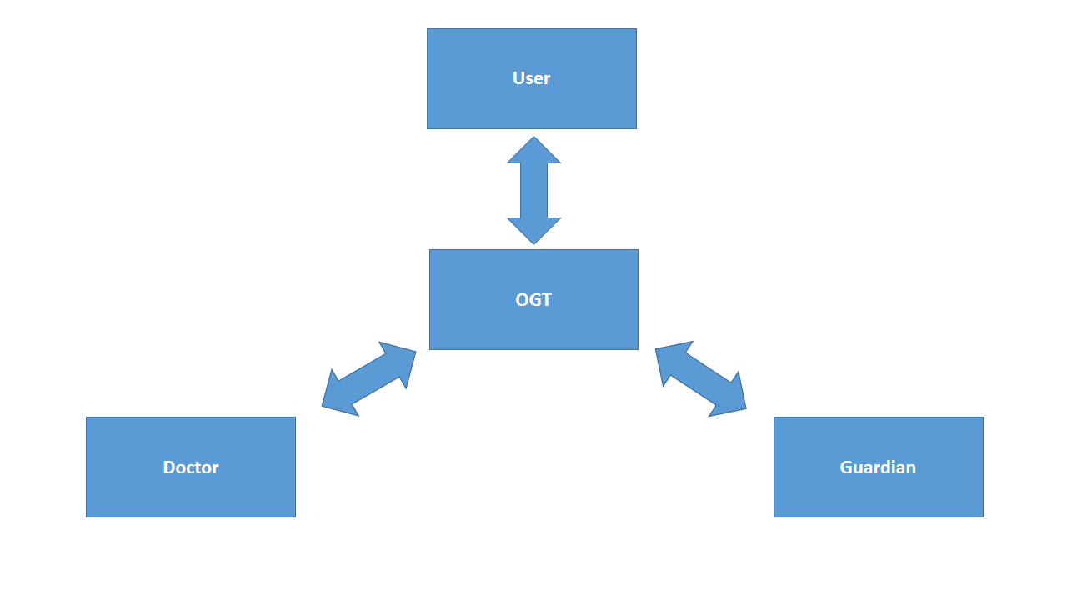

User Characteristics

The typical OGT users are not required to have special skills, since OGT provides a user friendly interface for peoples with different backgrounds.

User | Usage Frequency
Type I Diabetes Patient | Daily
Type I Diabetes Patients’ Guardian | Daily
Type I Diabetes Patients’ Doctor | Weekly

Constraint

The following constraints must be adhered to by the system:

- Application must be simple to implement and manage.
- Application must be able to store user’s data and transport data.
- Application must provide a Graphical User Interface.
- Application must allow multiple users to have access to user’s data.

System Requirements

- The application must be able to store data, including time, activity, location, and glucose level.
- The application can store different types of contacts.
- The application can make emergency calls and/or send emergency messages.
- The application can remind the user about the glucose levels.
- The application can accept manual input.
- The application can send messages between clients.
- The application will accommodate three types of data display:
- Daily
- Weekly
- Monthly

System Operation Rules

The OGT will have the following access functionality:

- User can create, delete, and edit user information and contacts.
- OGT can record user’s basic data automatically by a specific time interval.
- Application accept input glucose level and compare it with desired value.
- If the glucose level is in danger range, OGT will remind the user or contact guardians.
- User can input special activities and time.
- User can view the activities on maps and select the activities to view details.

Detailed Requirements

Requirements Overview

The following use-case overview and detailed use-case descriptions decompose the functionalities of OGT into fundamental components. The use-case models demonstrate the reusability of these components and the descriptions provide a narrative of the component functionality.

Functional Requirements

User Requirements Model – Use Case Overview
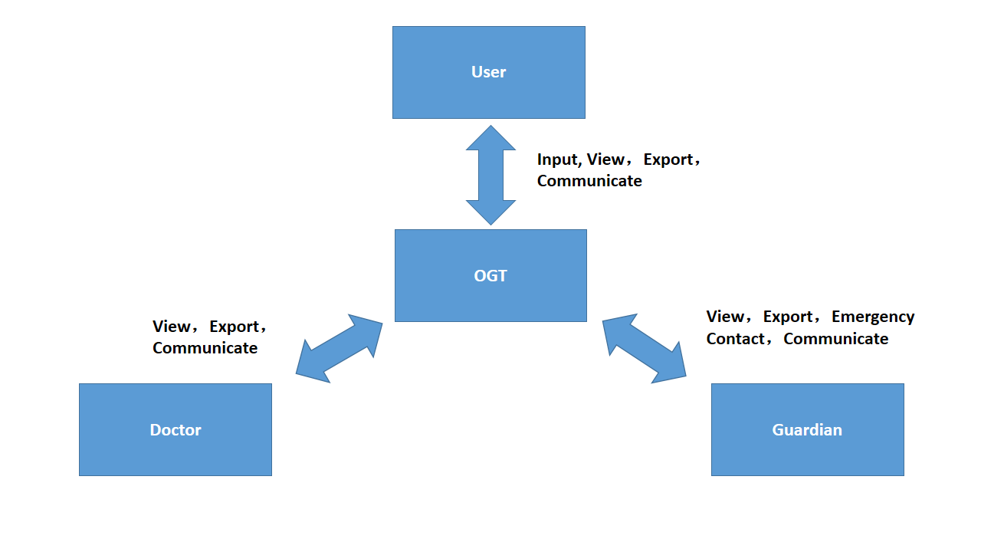

The table below offers a list of use cases. Detailed descriptions of the use cases are given in the Specifications section following this table. For the initial scope, only the first four use cases have the specifications completed in full detail. The others will be completed as time, resources, and priorities warrant.

Use Case ID | Use Case Name | Priority
URD OGT UC-001 | Login | Medium
URD OGT UC-002 | View Activity Map | High
URD OGT UC-003 | View Glucose Level | High
URD OGT UC-004 | Add Activities | High
URD OGT UC-005 | Add Glucose Level | High
URD OGT UC-006 | Make Emergency Call | High
URD OGT UC-007 | Send Message | Medium
URD OGT UC-008 | Add Account | Medium
URD OGT UC-009 | Edit Account | Medium
URD OGT UC-010 | Delete Account | Medium
URD OGT UC-011 | Select Display Type | Medium
URD OGT UC-012 | Search Location | Low
URD OGT UC-013 | Add Doctor | Medium
URD OGT UC-014 | Delete Doctor | Medium
URD OGT UC-015 | Add Guardian | Medium
URD OGT UC-016 | Delete Guardian | Medium

User Requirements Model – Detailed Use Case Specifications

Use Case ID: URD OGT UC-001 |  | Use Case Name: Login
Primary Actor(s): | User
Secondary Actor(s): | None
Description: | Username and password are required to log in.
Preconditions:
Normal Flow of Events: | User perform log in activity.
Postconditions: | The user is logged in.
Frequency of Use: | High
Alternative Flows: | None
Exceptions: | - If users’ name doesn’t exist, pop out notification, then return to log in status.  - If users’ name and password don’t match, pop out notification, then return to log in status.
Assumptions: | None
Issues: | None
Source: | None
Includes: | None
Associated Requirements: | None

Use Case ID: URD OGT UC-002 |  | Use Case Name: View Activity Map
Primary Actor(s): | User
Secondary Actor(s): | None
Description: | User choose to view the activities on map.
Preconditions: | None
Normal Flow of Events: | User choose to view the activities on map.
Postconditions: | None
Frequency of Use: | High
Alternative Flows: | None
Exceptions: | None
Assumptions: | None
Issues: | None
Source: | None
Includes: | Add Contact, Send Message, Make Emergency Call, Add Activities, Select Display Type
Associated Requirements: | None

Use-Case ID: URD OGT UC-003 |  | Use-Case Name: View Glucose Level
Primary Actor(s): | User
Secondary Actor(s): | None
Description: | User choose to view glucose level
Preconditions: | None
Post-conditions: | None
Frequency of Use: | High
Exceptions: | None
Includes: | Add Contact, Send Message, Make Emergency Call, Add Glucose Level, Select Display Type
Associated Requirements: | None

Use-Case ID: URD OGT UC-004 |  | Use-Case Name: Add Activities
Primary Actor(s): | User
Secondary Actor(s): | None
Description: | User can add activities to OGT
Preconditions: | User choose to add activities.
Post-conditions: | Custom activities are added.
Frequency of Use: | High
Primary Course: | Add activities are chosen.
Alternative Courses: | None
Exceptions: | None
Includes: | None
Associated Requirements: | None

Technical Requirements

Operational and Development Environments
OGT must run on Android device with message, phone, location, SQLite database service and GPS sensor.

APPENDIX A

Glossary of Terms

The definitions listed here establish meanings within the context of this document.

Term | Definition
OGT | OmniGlucoseTracker
User | Type I diabetes patients
Guardian | Type I diabetes patients’ guardian for emergency contact

Priority: High, Medium or Low

